**Project Design Phase-II**

**Data Flow Diagram & User Stories**

|  |  |
| --- | --- |
| Date |  |
| Team ID | LTVIP2025TMID59401 |
| Project Name | SmartSDLC – AI-Enhanced Software Development Lifecycle |
| Maximum Marks | 4 Marks |

**1. Data Flow Diagram (DFD)**

The Data Flow Diagram (DFD) of SmartSDLC illustrates how data flows between the user interface, backend, and internal processing modules. It emphasizes modular communication and separation of responsibilities.

- Users upload PDF documents or enter prompts/code via the frontend.  
- The backend dispatches the input to the appropriate module: classifier, generator, fixer, etc.  
- AI models process the input and return structured output.  
- Output (like code, test cases, summaries) is rendered back on the frontend.

**Figure: SmartSDLC Data Flow Diagram**

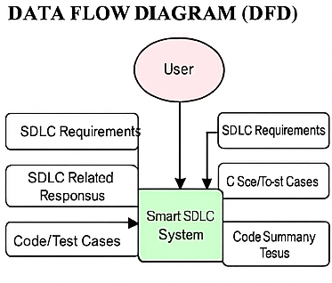

**2. User Stories**

The following user stories represent how different users interact with the SmartSDLC system. Each story focuses on user needs and expected system responses.

|  |  |  |
| --- | --- | --- |
| User Story ID | Description | Acceptance Criteria |
| US1 | As a user, I want to upload a PDF with software requirements so the system can classify them. | The uploaded document is processed, and sections are labeled by SDLC phase. |
| US2 | As a user, I want to ask the chatbot SDLC-related questions. | The chatbot responds with correct and context-aware answers. |
| US3 | As a user, I want to generate code from a requirement description. | Python code matching the input logic is displayed. |
| US4 | As a user, I want to submit buggy code and receive a fixed version. | Corrected code is shown and explained. |
| US5 | As a user, I want to generate test cases from my code. | Test functions using unittest or pytest are returned. |
| US6 | As a user, I want a summary of my code’s functionality. | The output includes a readable explanation of logic and structure. |